# CS 255 System Design Document Template

## UML Diagrams

### UML Use Case Diagram

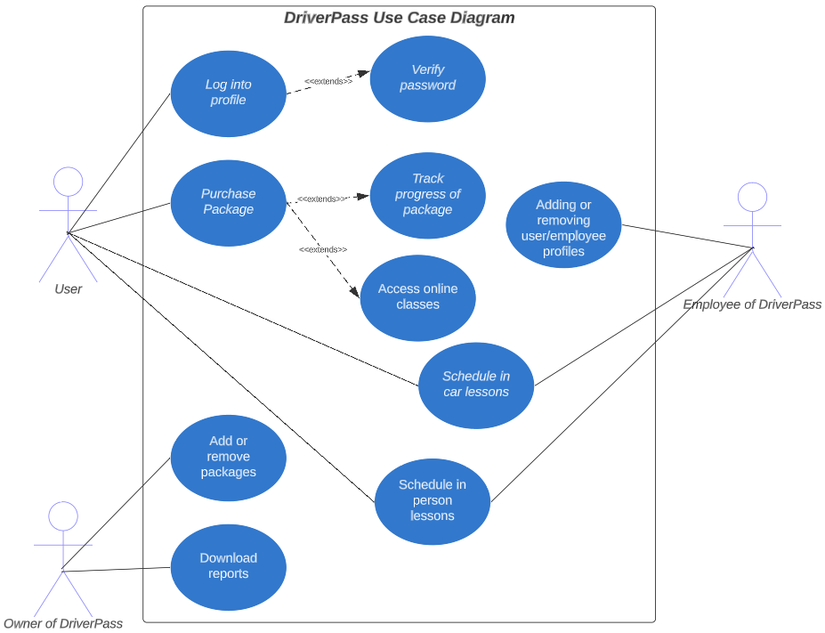

### UML Activity Diagrams

**Track Package Progress**

**Resetting password for students/employees and removing profiles for terminated employees**

### UML Sequence Diagram

### UML Class Diagram

## Technical Requirements

      The DriverPass diagrams shown above have brought some technical requirements to light. Those requirements are that the cloud based system needs to be up-to-date with malware and virus protection in order for the system to detour potential threats to the system. Another technical requirement is that the system needs to be fast. This will enable the student to be happy with the little to no wait times when it comes to loading web-pages and/or taking the practice tests and waiting for the results.

      Another requirement is that it needs to be  readily available for when the student has time in their day to learn the material. Since that student is taking time out of his/her day, we need to make sure that the system is ready to go whenever they need it. Also, since the system abides by the policies and regulations of the DMV, it needs to be updated frequently in order to be reliable. The consistent communication with the DMV systems will ensure that the system is reliable and will abide by the updated rules and regulations whenever there is a change.